201801-201808，向上跳空缺口，剔除新股和涨幅超过9%

赢利超过20%

## 东诚药业

|  |  |  |  |
| --- | --- | --- | --- |
| 2018/3/27 | 2675 | 东诚药业 | **20.14%** |

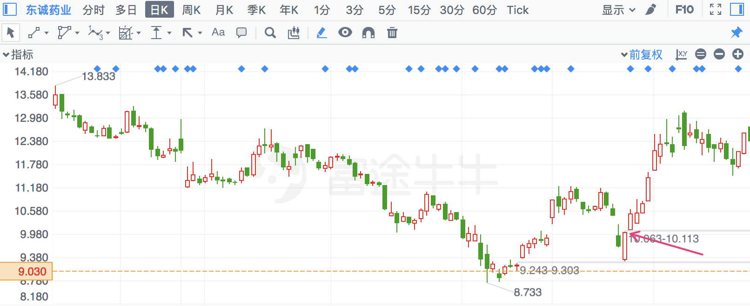

## 瀛通通讯

|  |  |  |  |
| --- | --- | --- | --- |
| 2018/3/6 | 2861 | 瀛通通讯 | **20.20%** |

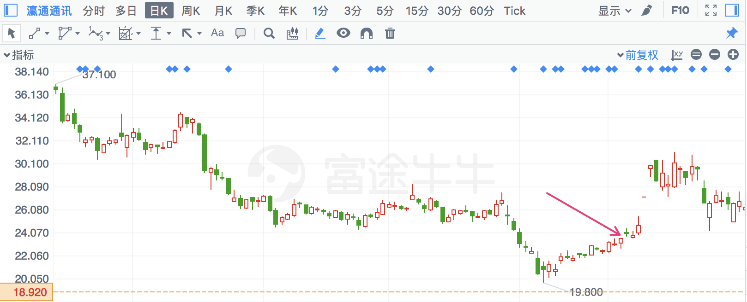

## 华中数控

|  |  |  |  |
| --- | --- | --- | --- |
| 2018/3/27 | 300161 | 华中数控 | **20.23%** |

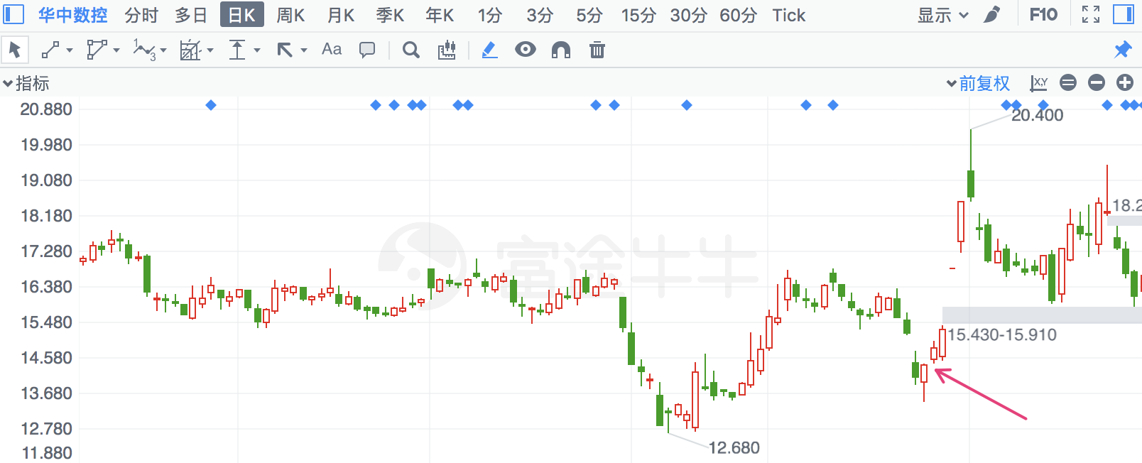

## 岭南股份

|  |  |  |  |
| --- | --- | --- | --- |
| 2018/2/22 | 2717 | 岭南股份 | **20.23%** |

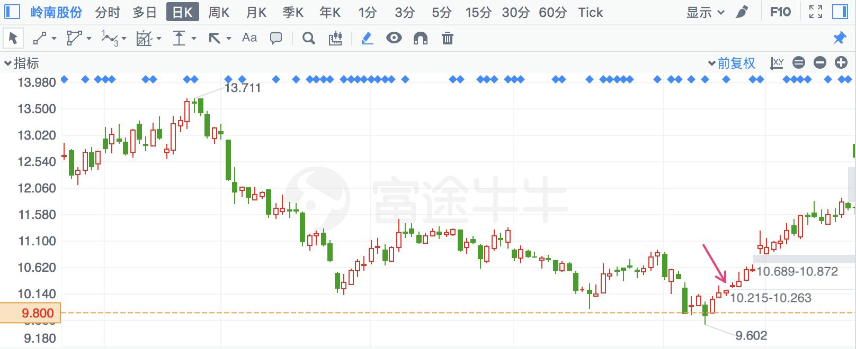

## 信息发展

|  |  |  |  |
| --- | --- | --- | --- |
| 2018/2/28 | 300469 | 信息发展 | **20.44%** |

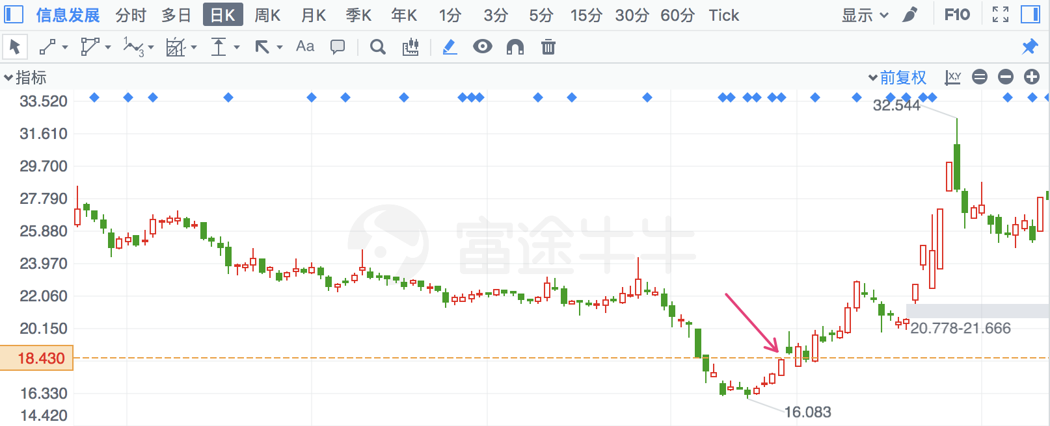

## 金石东方

|  |  |  |  |
| --- | --- | --- | --- |
| 2018/3/27 | 300434 | 金石东方 | **20.78%** |

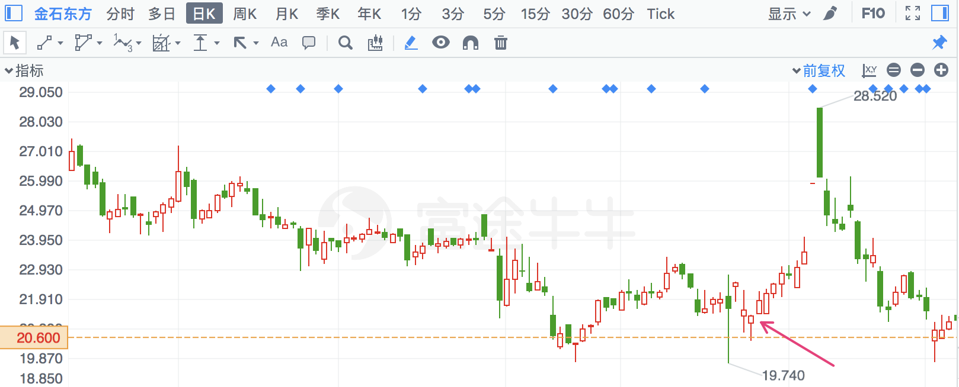

## 寒锐钴业

|  |  |  |  |
| --- | --- | --- | --- |
| 2018/7/10 | 300618 | 寒锐钴业 | **20.79%** |

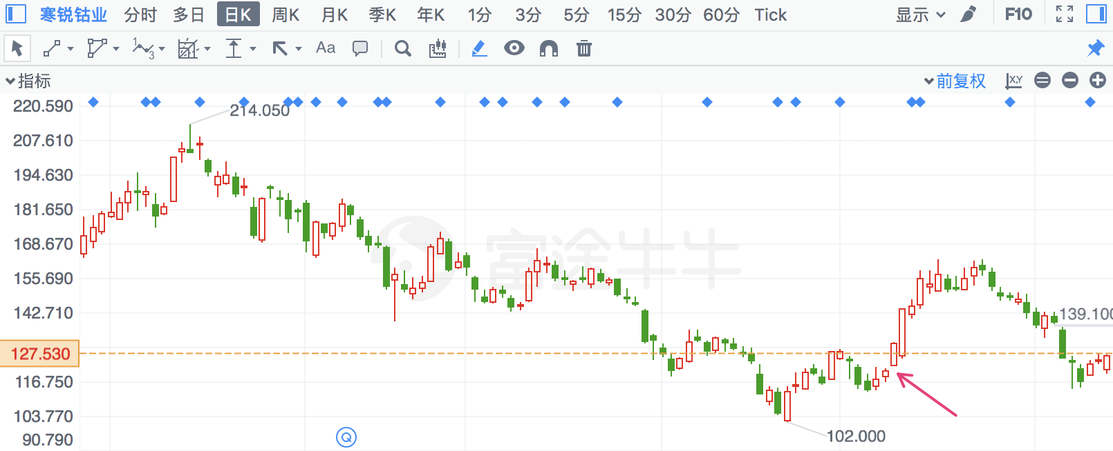

## 先导智能

|  |  |  |  |
| --- | --- | --- | --- |
| 2018/2/26 | 300450 | 先导智能 | **20.91%** |

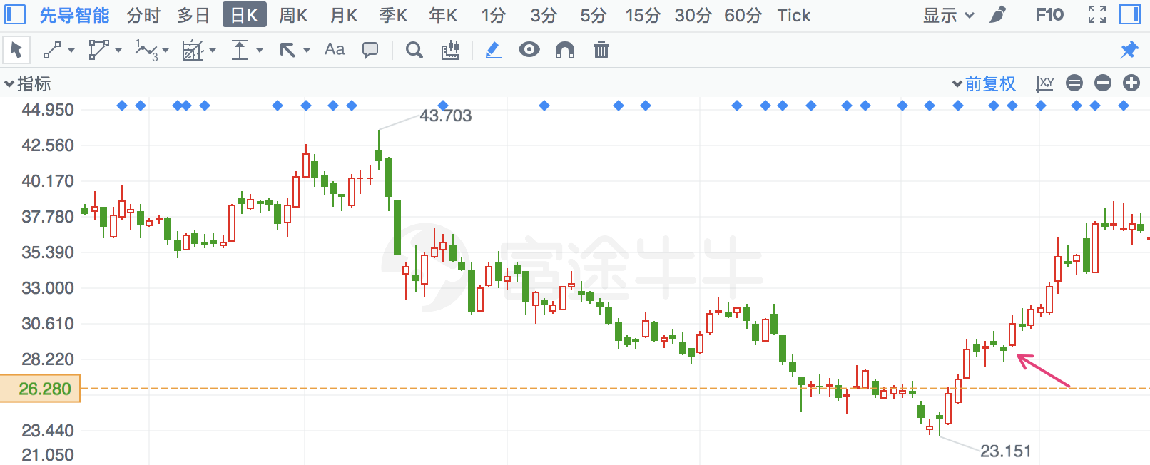

## 千方科技

|  |  |  |  |
| --- | --- | --- | --- |
| 2018/2/23 | 2373 | 千方科技 | **20.97%** |

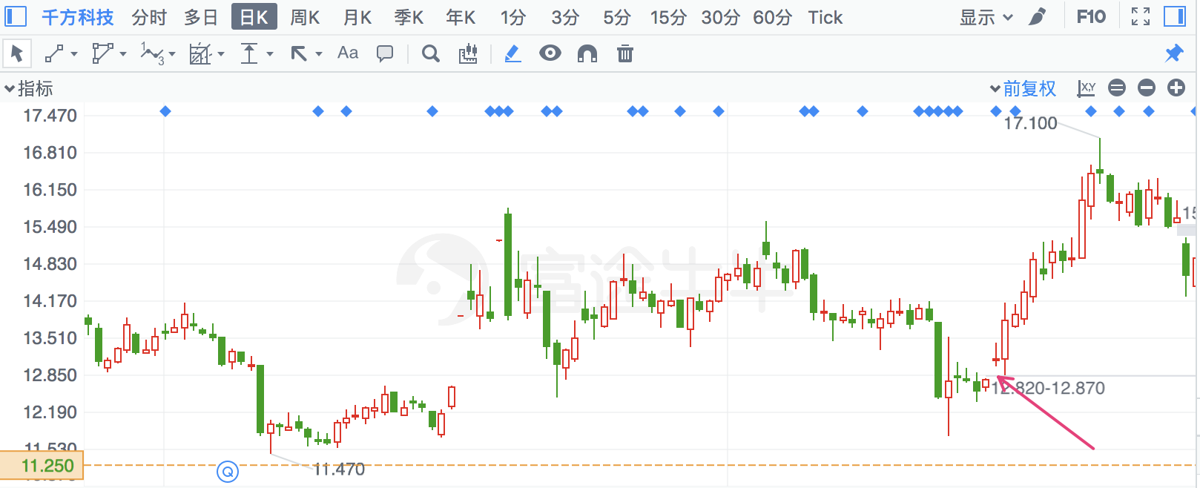

## 扬帆新材

|  |  |  |  |
| --- | --- | --- | --- |
| 2018/3/27 | 300637 | 扬帆新材 | **21.68%** |

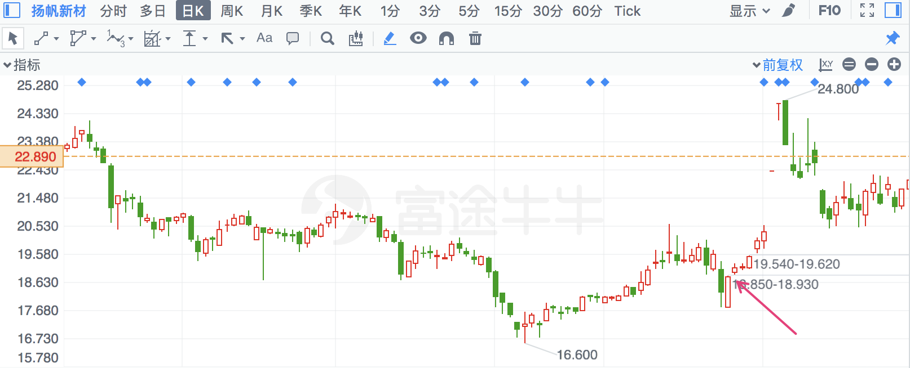

## 恒泰艾普

|  |  |  |  |
| --- | --- | --- | --- |
| 2018/5/8 | 300157 | 恒泰艾普 | **21.77%** |

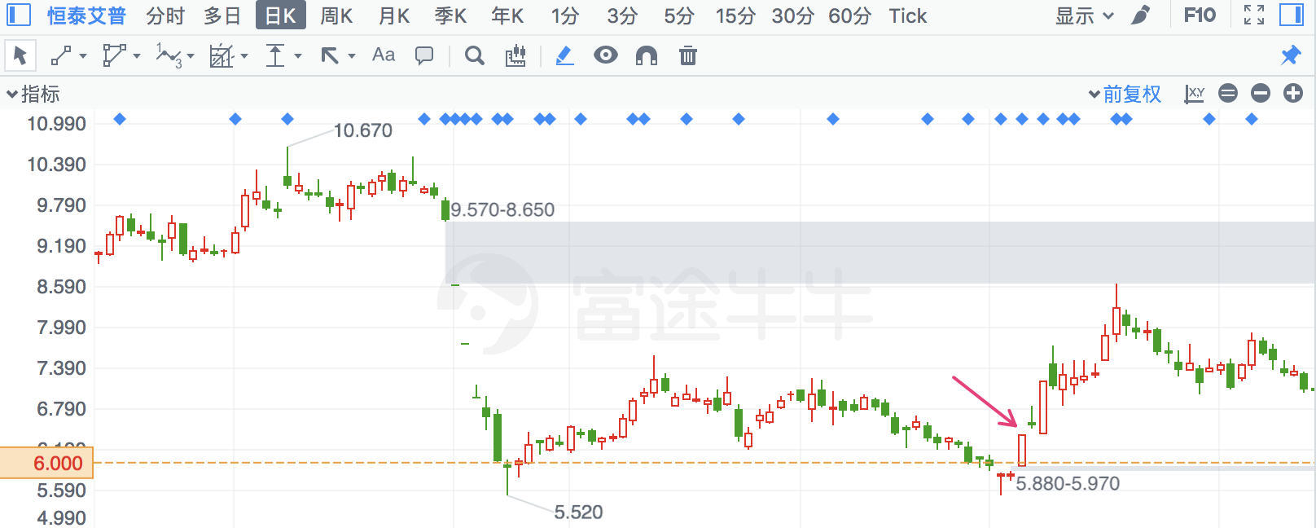

## 雪莱特

|  |  |  |  |
| --- | --- | --- | --- |
| 2018/3/27 | 2076 | 雪莱特 | **21.91%** |

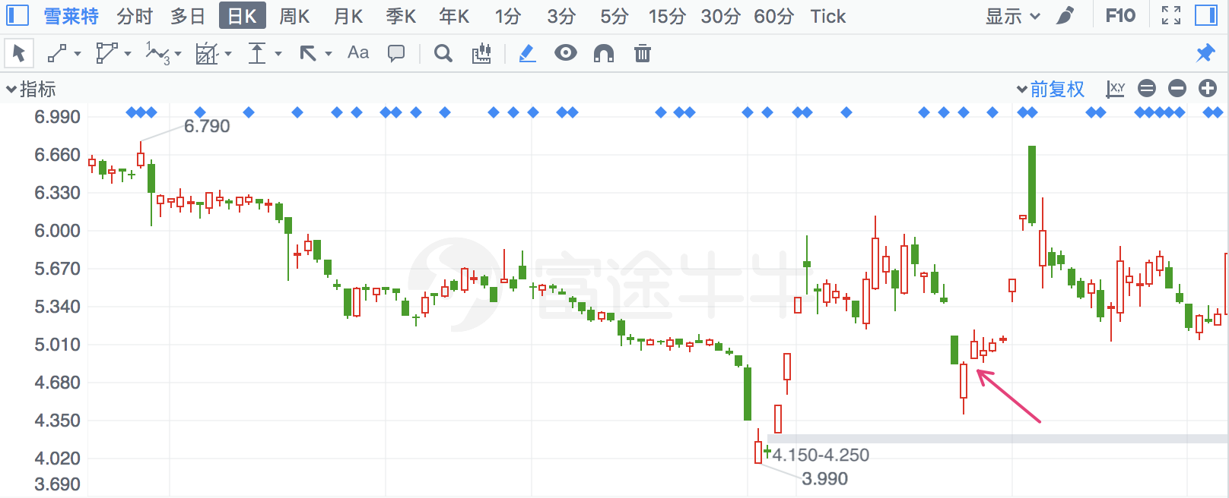

## 智度股份

|  |  |  |  |
| --- | --- | --- | --- |
| 2018/4/2 | 676 | 智度股份 | **22.17%** |

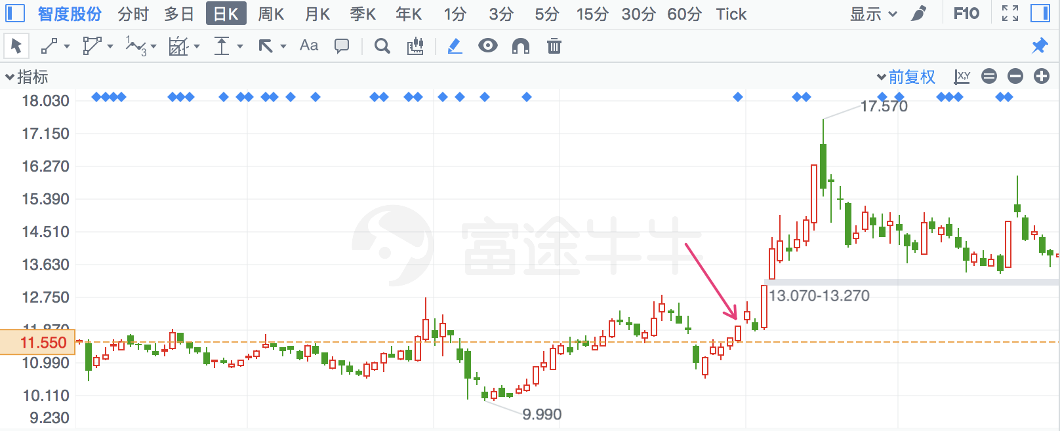

## 汇金科技

|  |  |  |  |
| --- | --- | --- | --- |
| 2018/2/26 | 300561 | 汇金科技 | **22.24%** |

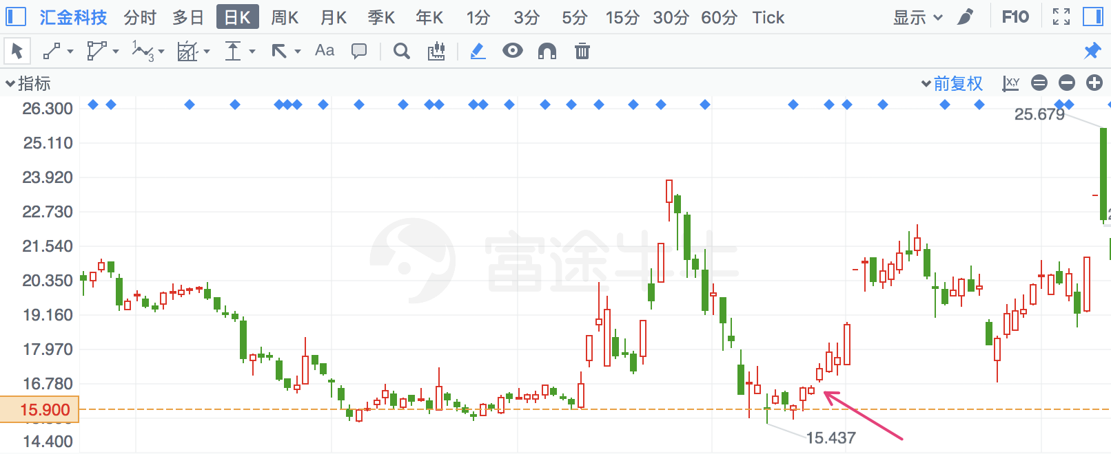

## 深华发A

|  |  |  |  |
| --- | --- | --- | --- |
| 2018/5/2 | 20 | 深华发A | **22.33%** |

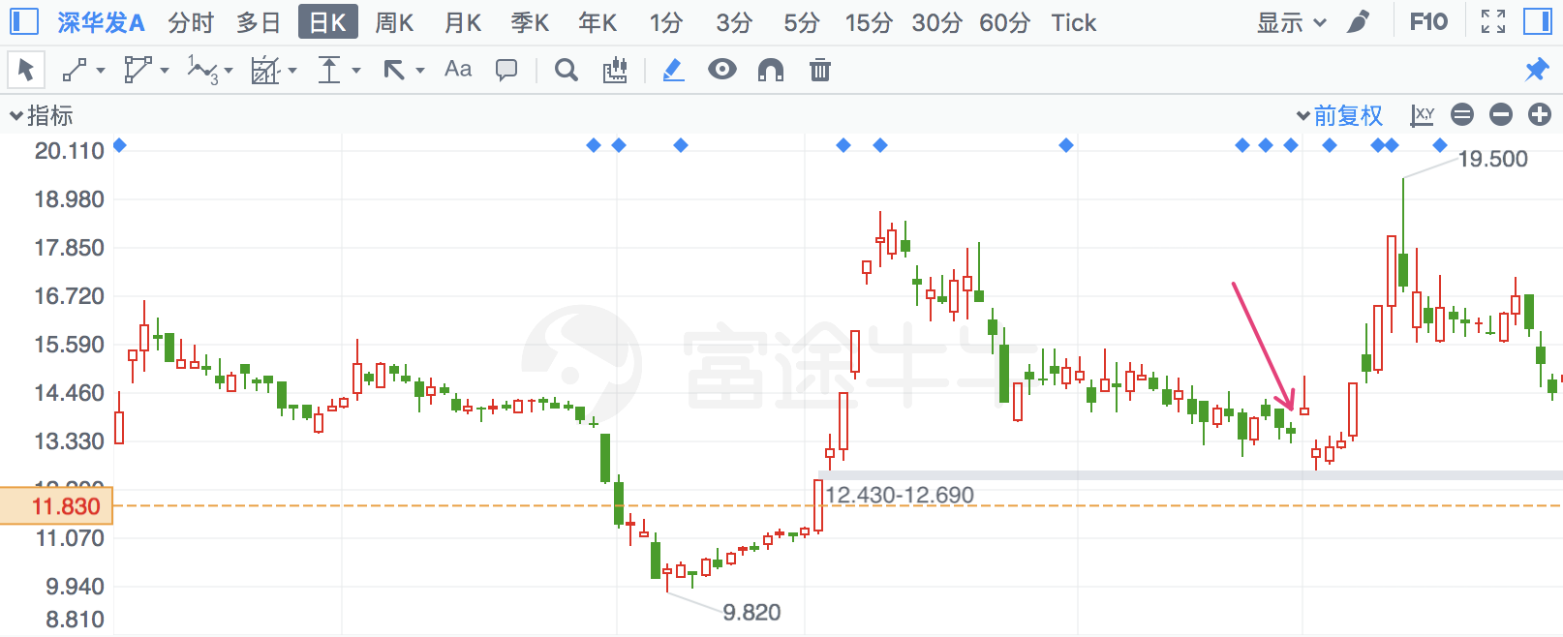

## 大庆华科

|  |  |  |  |
| --- | --- | --- | --- |
| 2018/7/24 | 985 | 大庆华科 | **22.48%** |

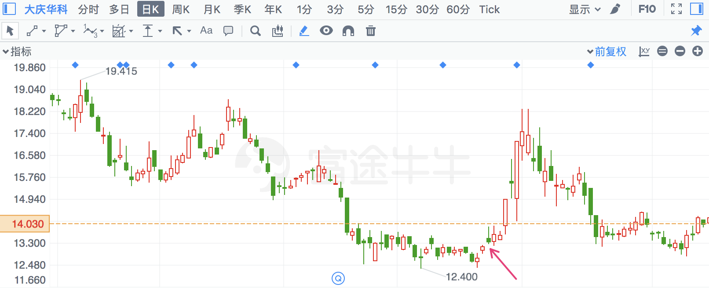

## 百润股份

|  |  |  |  |
| --- | --- | --- | --- |
| 2018/2/22 | 2568 | 百润股份 | **22.67%** |

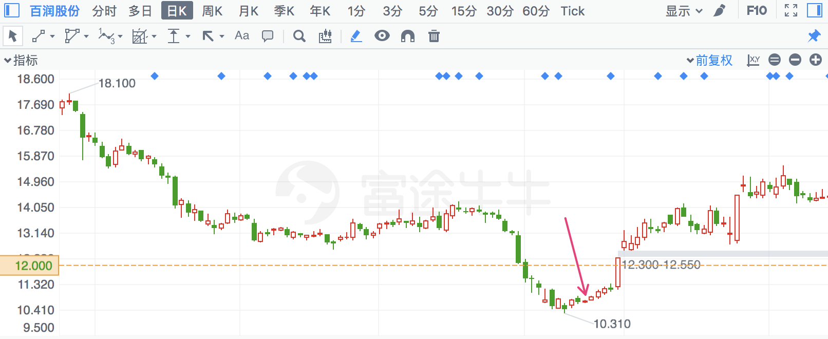

## 花王股份

|  |  |  |  |
| --- | --- | --- | --- |
| 2018/2/13 | 603007 | 花王股份 | **22.72%** |

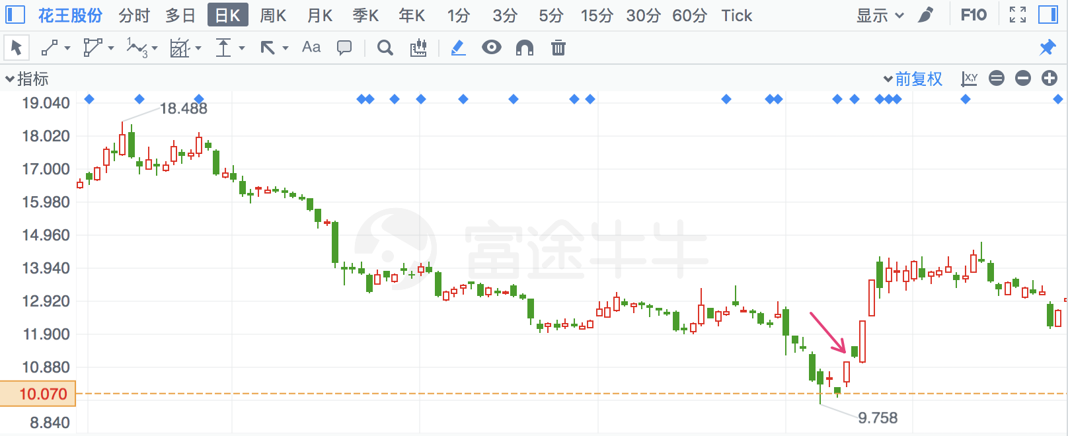

## 风华高科

|  |  |  |  |
| --- | --- | --- | --- |
| 2018/7/10 | 636 | 风华高科 | **22.78%** |

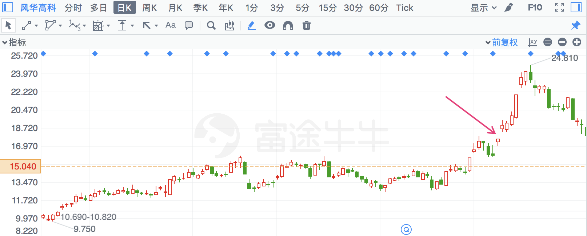

## 南宁百货

|  |  |  |  |
| --- | --- | --- | --- |
| 2018/7/24 | 600712 | 南宁百货 | **23.22%** |

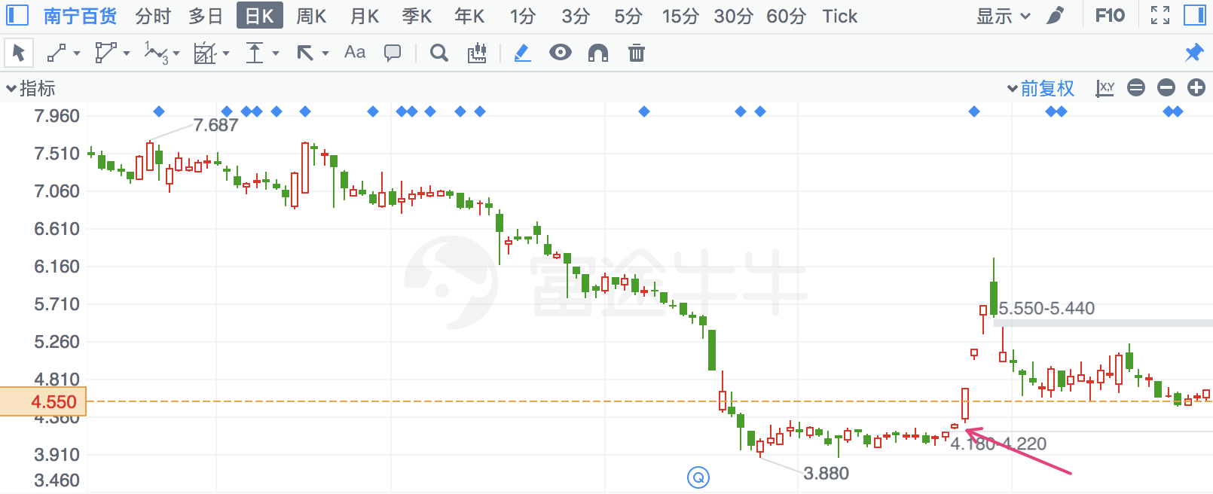

## 世茂股份

|  |  |  |  |
| --- | --- | --- | --- |
| 2018/1/2 | 600823 | 世茂股份 | **23.75%** |

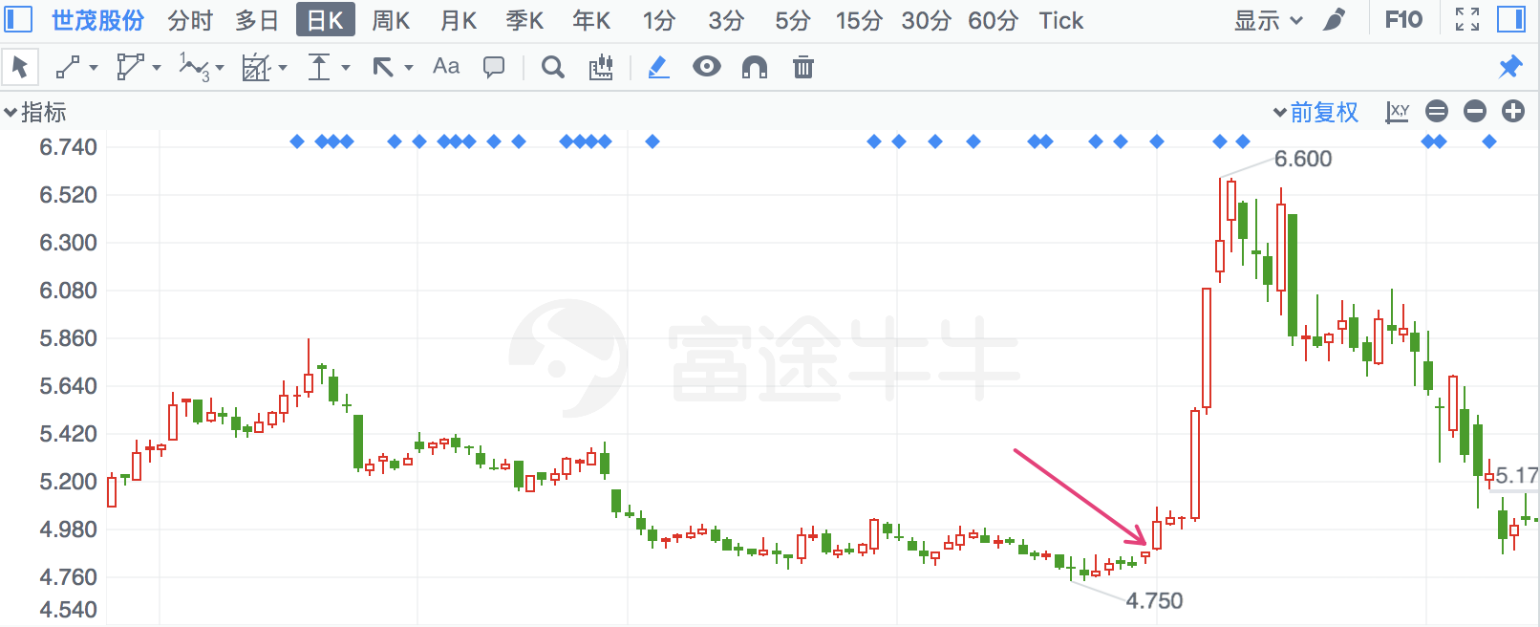

## 金银河

|  |  |  |  |
| --- | --- | --- | --- |
| 2018/3/27 | 300619 | 金银河 | **24.09%** |

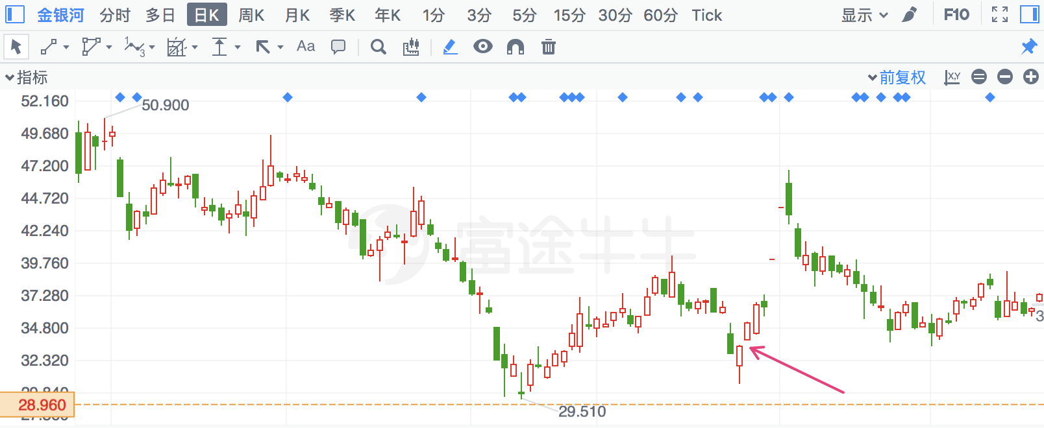

## 苏交科

|  |  |  |  |
| --- | --- | --- | --- |
| 2018/7/12 | 300284 | 苏交科 | **24.78%** |

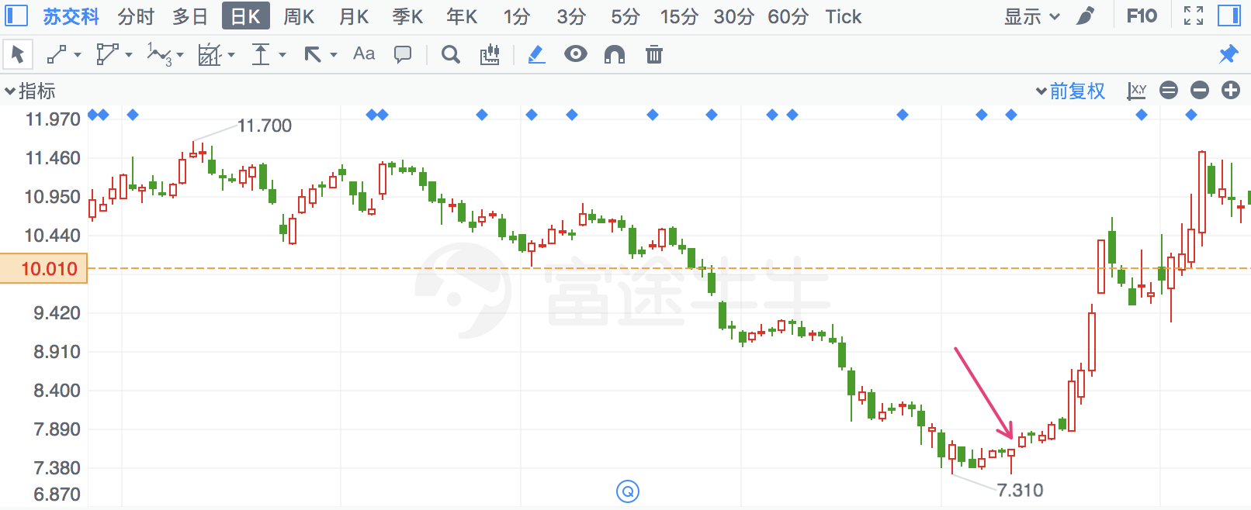

## 江丰电子

|  |  |  |  |
| --- | --- | --- | --- |
| 2018/2/27 | 300666 | 江丰电子 | **26.30%** |

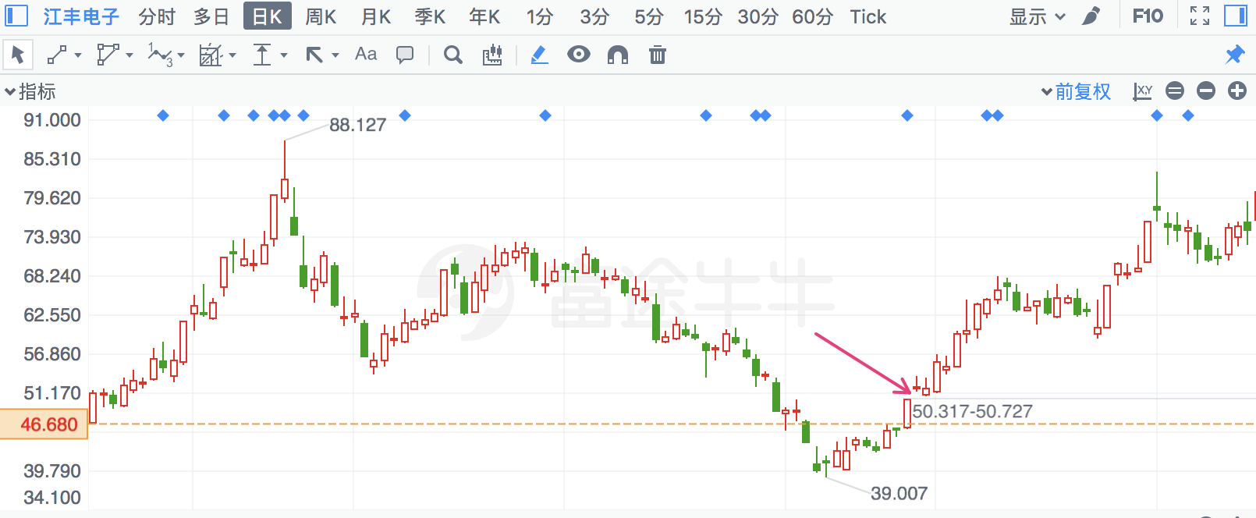

## 国科微

|  |  |  |  |
| --- | --- | --- | --- |
| 2018/2/27 | 300672 | 国科微 | **27.68%** |

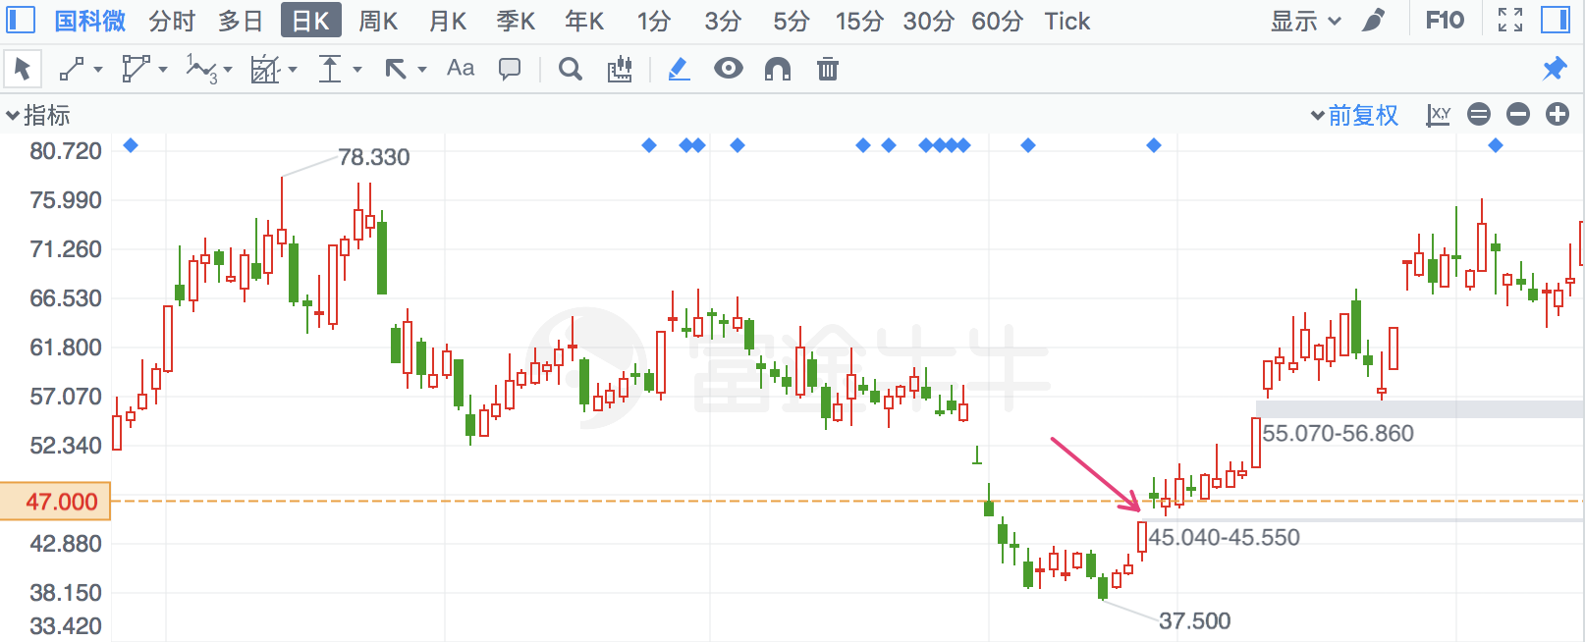

## 佳都科技

|  |  |  |  |
| --- | --- | --- | --- |
| 2018/3/1 | 600728 | 佳都科技 | **27.84%** |

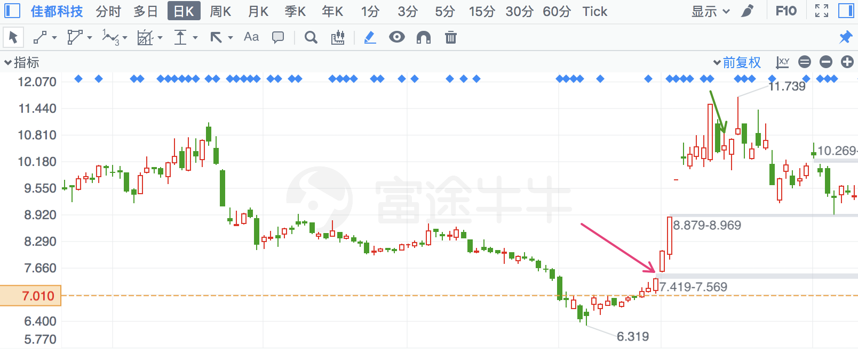

## 赛意信息

|  |  |  |  |
| --- | --- | --- | --- |
| 2018/2/26 | 300687 | 赛意信息 | **28.85%** |

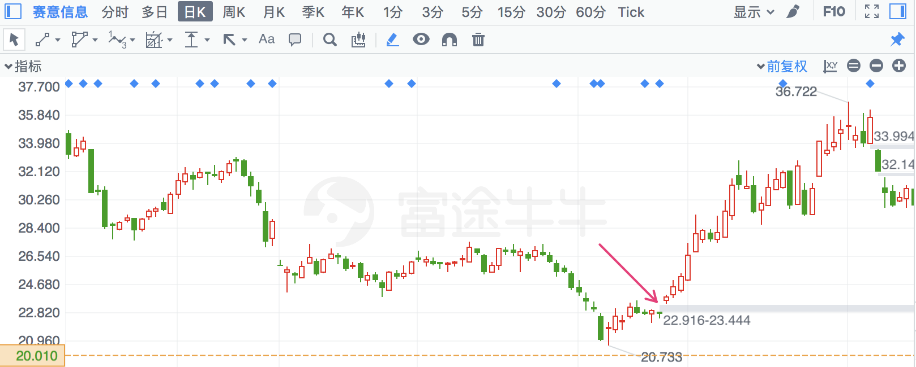

## 启明信息

|  |  |  |  |
| --- | --- | --- | --- |
| 2018/2/22 | 2232 | 启明信息 | **28.95%** |

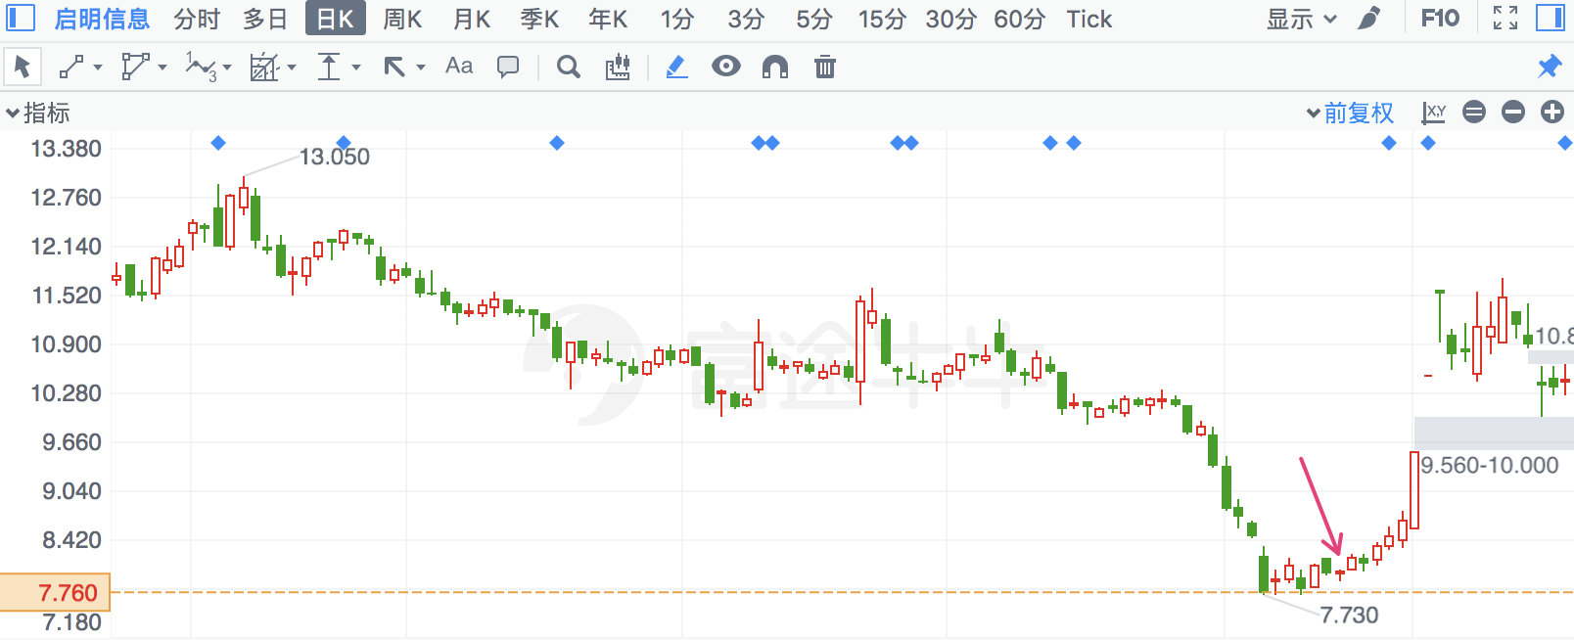

## 洛阳钼业

|  |  |  |  |
| --- | --- | --- | --- |
| 2018/2/13 | 603993 | 洛阳钼业 | **29.00%** |

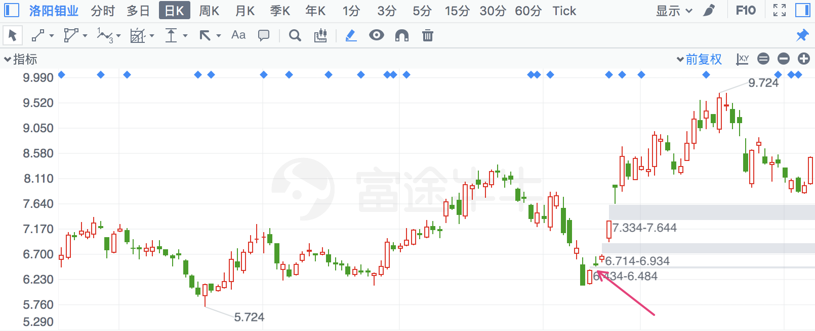

## 华夏幸福

|  |  |  |  |
| --- | --- | --- | --- |
| 2018/1/2 | 600340 | 华夏幸福 | **30.06%** |

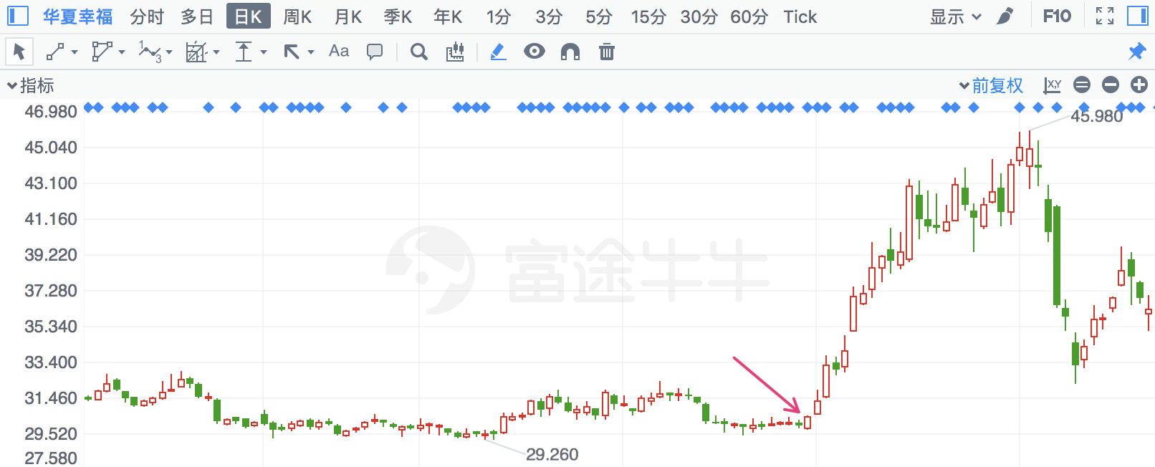

## 九有股份

|  |  |  |  |
| --- | --- | --- | --- |
| 2018/3/12 | 600462 | 九有股份 | **30.52%** |

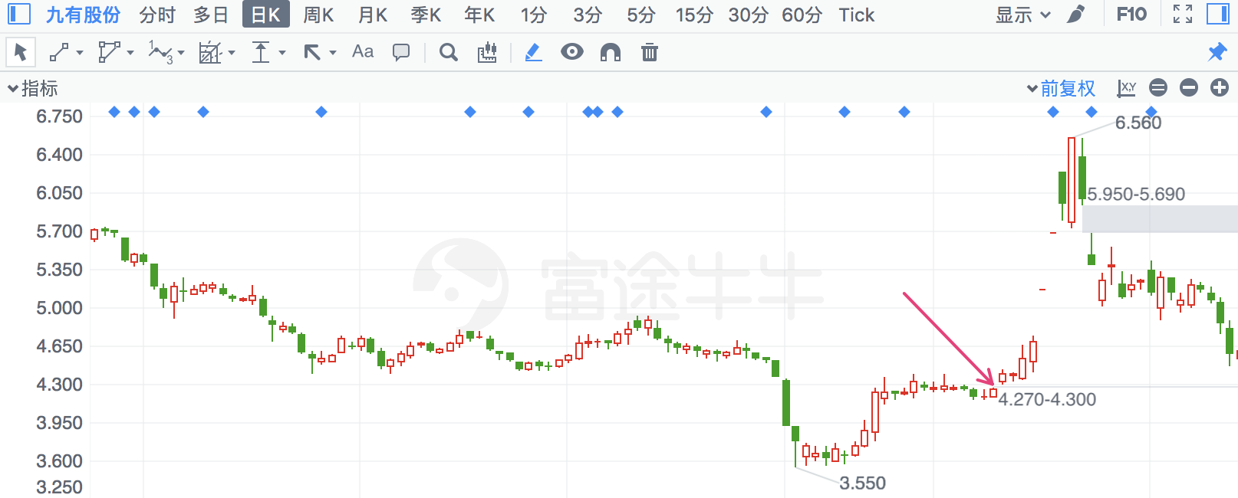

## 胜宏科技

|  |  |  |  |
| --- | --- | --- | --- |
| 2018/2/5 | 300476 | 胜宏科技 | **32.37%** |

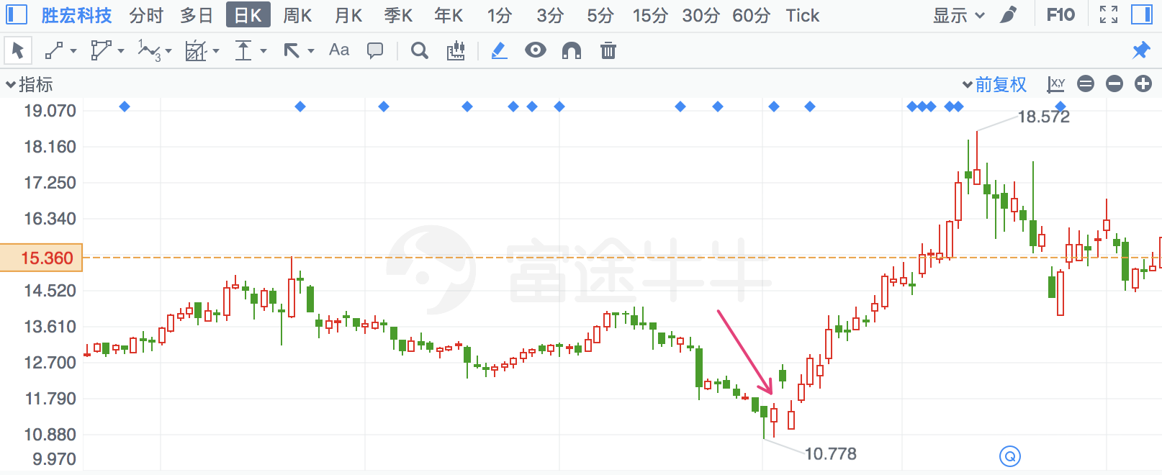

## 金安国纪

|  |  |  |  |
| --- | --- | --- | --- |
| 2018/7/13 | 2636 | 金安国纪 | **32.49%** |

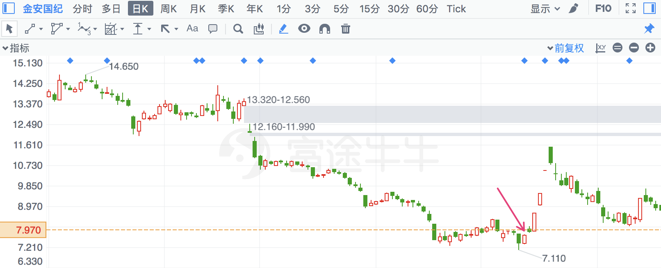

## 深华发A

|  |  |  |  |
| --- | --- | --- | --- |
| 2018/3/5 | 20 | 深华发A | **33.71%** |

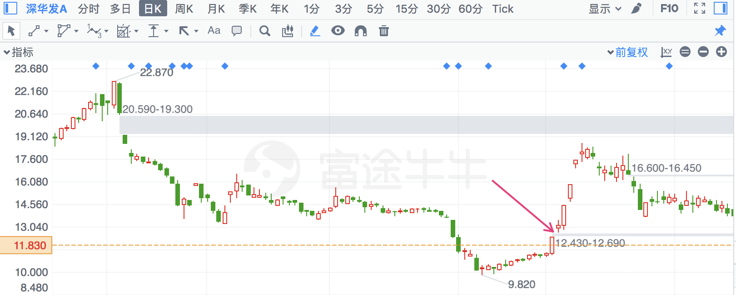

## 民和股份

|  |  |  |  |
| --- | --- | --- | --- |
| 2018/4/24 | 2234 | 民和股份 | **35.47%** |

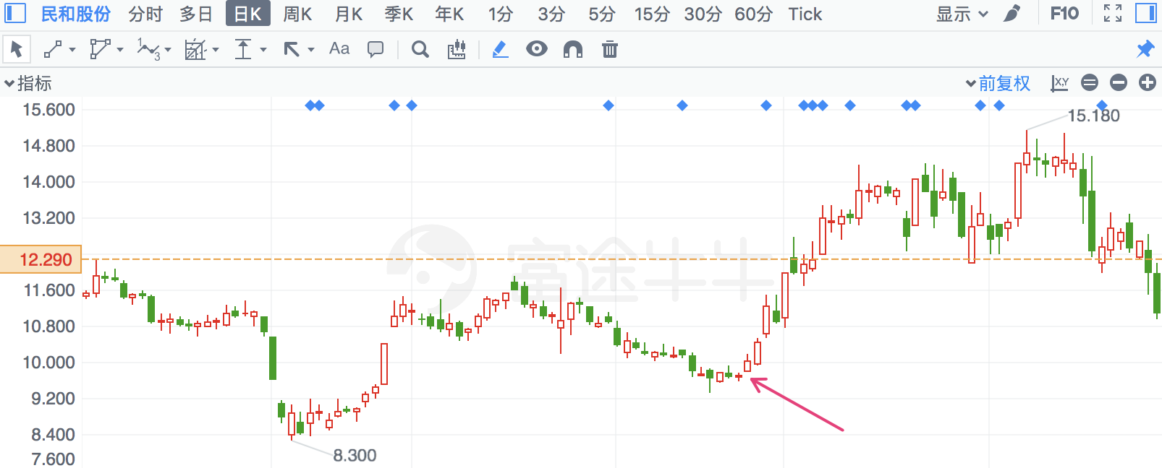

## 用友网络

|  |  |  |  |
| --- | --- | --- | --- |
| 2018/2/13 | 600588 | 用友网络 | **37.23%** |

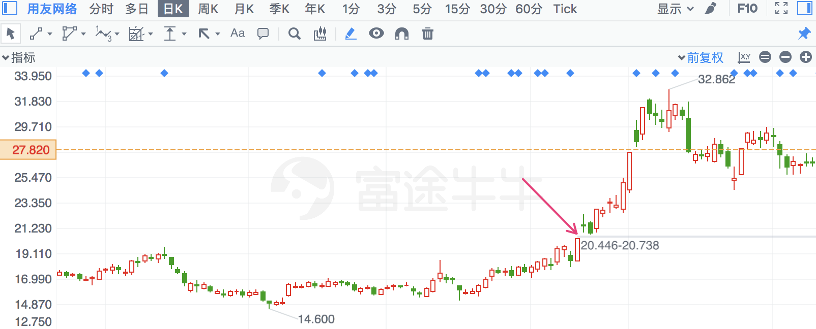

## 普路通

|  |  |  |  |
| --- | --- | --- | --- |
| 2018/2/12 | 2769 | 普路通 | **42.43%** |

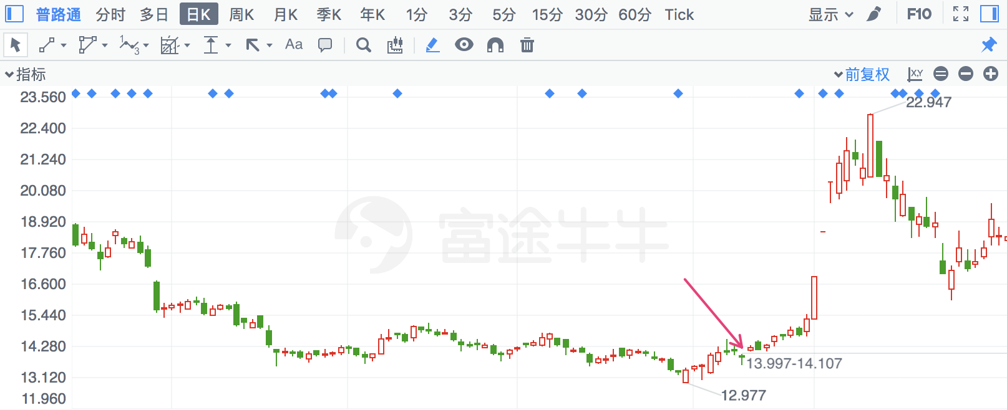

## 威唐工业

|  |  |  |  |
| --- | --- | --- | --- |
| 2018/2/22 | 300707 | 威唐工业 | **45.09%** |

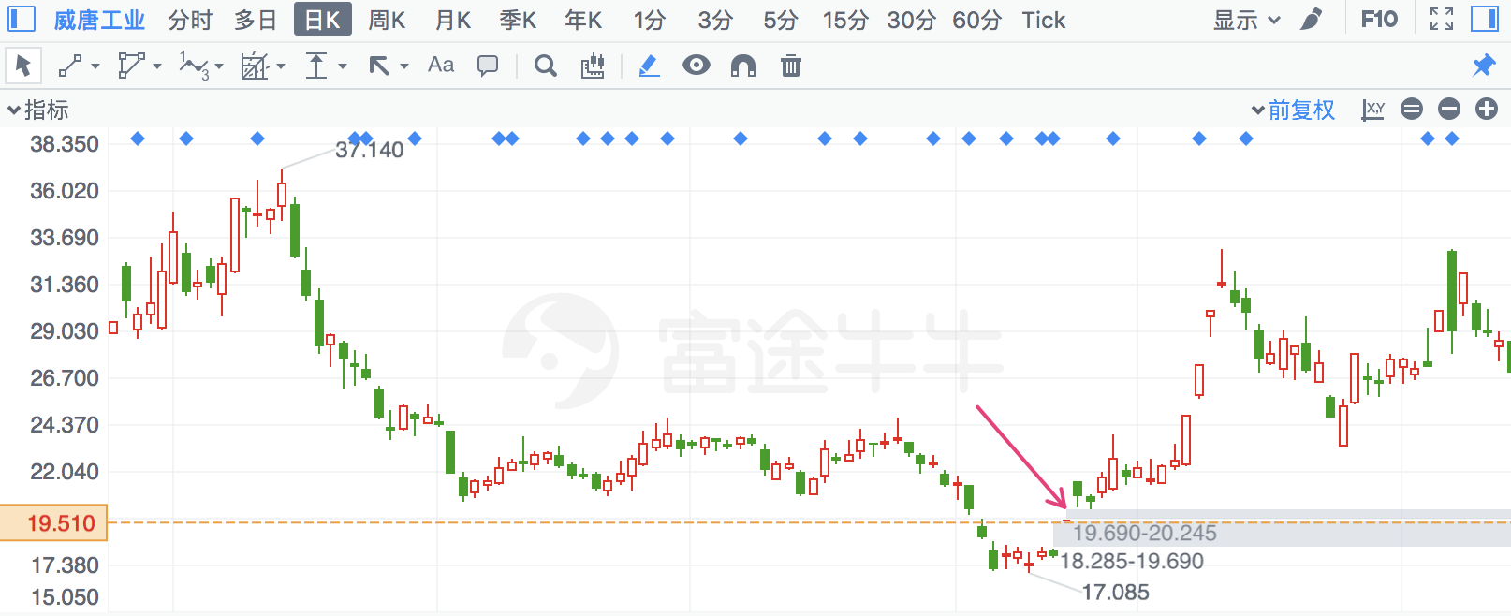

## 正海生物

|  |  |  |  |
| --- | --- | --- | --- |
| 2018/3/27 | 300653 | 正海生物 | **50.40%** |

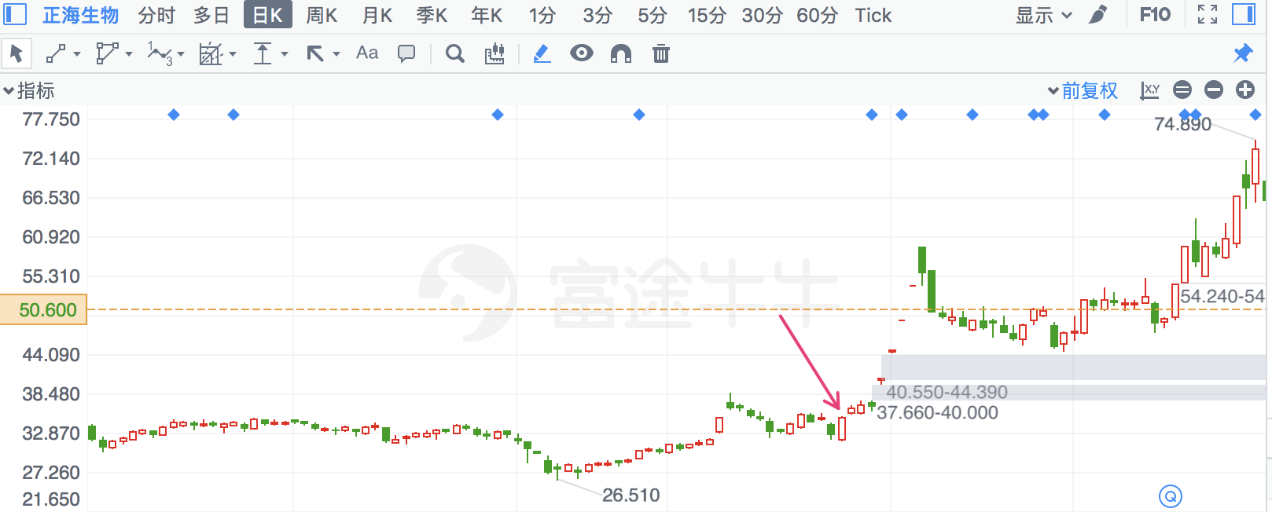

## 华铭智能

|  |  |  |  |
| --- | --- | --- | --- |
| 2018/2/8 | 300462 | 华铭智能 | **54.89%** |

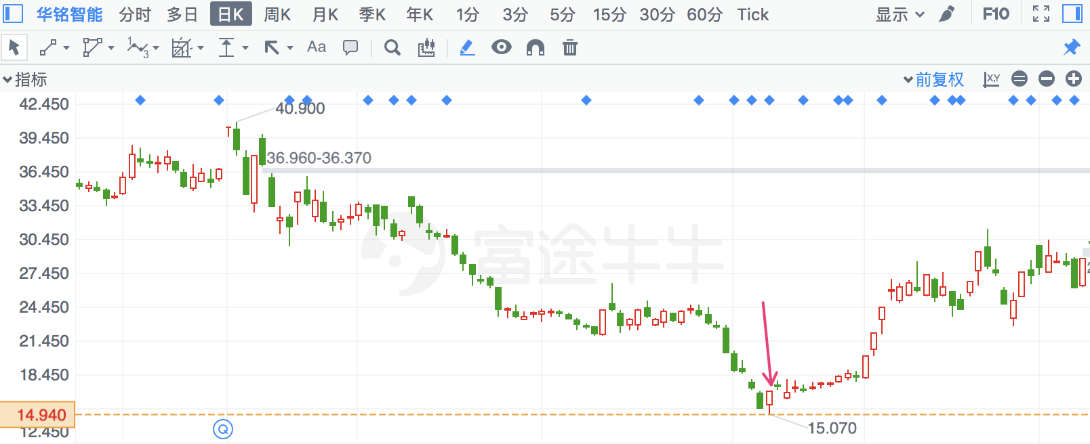

## 大烨智能

|  |  |  |  |
| --- | --- | --- | --- |
| 2018/3/27 | 300670 | 大烨智能 | **55.76%** |

